PSD (versie 1, 01/11/2016 21:05)

Groep 4

|  |
| --- |
| api_url = 'http://webservices.ns.nl/ns-api-avt?station=amsterdam' |

|  |
| --- |
| api_url = 'http://webservices.ns.nl/ns-api-avt?station=ut' |

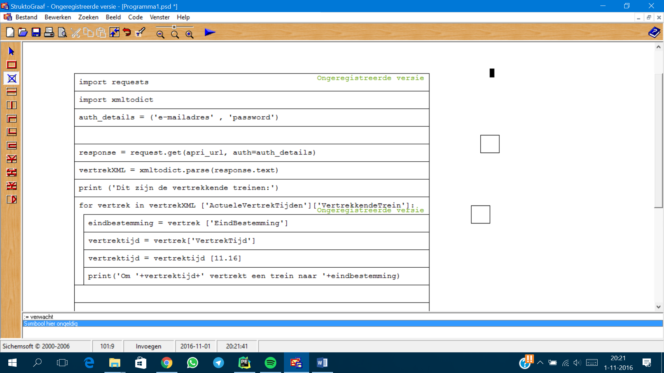

***1PSD NS.py***

**2PSD NSAmsterdam.py**

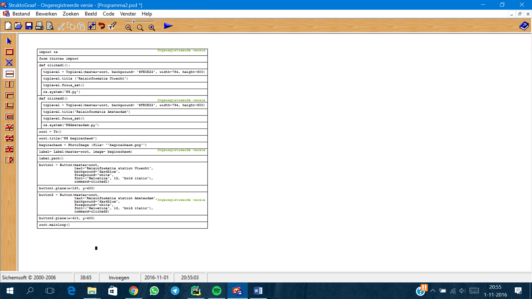

***3 PSD GUI.py***